CURRICULAM VITAE

RIZWAN KHAN 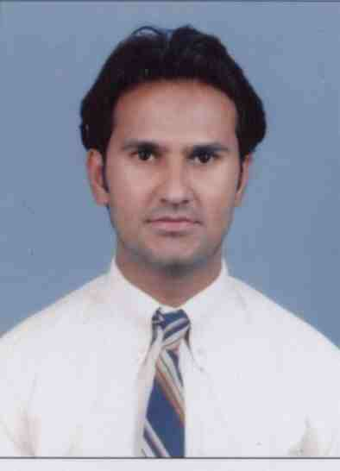

India
Nagpur
Mob no: +91-9833964506
Email: khanrizwan_1999@yahoo.com

_________________________________________________________

CAREER OBJECTIVE
To be part of the Dynamic, Professional & Result Oriented Organization this actualizes my skills, potentials and thereby organizational growth

Professional Profile

Experienced professional with proven track record of success in marketing and also in direct sales & service industry. Exposure to international marketing for sales and services. Good at communicating with top management, vendors and internal departments to co-ordinate overall marketing efforts for organization growth.

Operations: Have successfully handled assignments as a Sales Manager, in planning and execution, besides handling front and back end processing. Have demonstrated ability in initiating driving and managing changes.

Business Development: Possess a thorough understanding of business process, product launches, promotions, market intelligence, and customer retention, direct/corporate sales in the product concept & service industry. Highly competitive in nature and strongly driven by results.

People Management: Decisive team player, who highly values teamwork, believes in the power of delegation and constantly strives to develop talent and skills. Believes in fostering team spirit and propel revenue growth and consistently exceed goals. Process excellent interpersonal, communication and presentation skills.

Work Preferences:-

Desired Job Type : Full Time
Highest Education Level : B.Com
Certification : OCP Certificate
Current Location : India (Nagpur)
Driving License : KSA Light Vehicle

Technical Skill:

Databases : ORACLE 8i, 9i and 10g, OCP Certified.

Languages : PL/SQL, SQL Plus and C & C++.

OS : Red Hat Linux, UNIX, Windows XP, Windows NT 4.0 Server,
Windows 2000 Server, Windows NT/98/95, Windows 2000.

Tools : OEM, TOAD, SQLbacktrack, Data point, Stats pack.

Professional Exposure:

Verchaska Infotech PVT.LTD. (Mumbai- Vashi)

Worked as a Sales Manager
From Aug 2012 – Sep 2013.
Knowledge of international business approaches and cultural sensitivities gained while living and working in varied Indian & Middle Eastern.

Extensive knowledge and experience in selling software development, offshore development, package implementation services and consulting services to large and crucial accounts.

Presenting the company to potential clients through direct communication and face to face meetings, telephone calls and emails.
Responsible for my own lead generation and appointment setting.
Actively and successfully manage the sales process: lead generation; credentials pitch; asking questions; solution pitch; negotiation; close; handover to the account management team
Possess drive.

Motivation and acute attention to detail in ensuring all sales opportunities represent the company in a professional manner and polished manner which will aid the intention
of gaining new business leads and contacts.

2Share Emerging Technology (Saudi Arabia Riyadh)

Worked as Sales Account Manager
From September 2011 – July 2012
Mobile Application Air Flight Booking System, Mobile Hotel Booking, Contact Centre Solutions, Information Technology Solutions, Mobile Apps & Web Services, Bulk SMS, and Mobile e-Government Solutions, Health care Solutions & Media Project.
Mobile Application Flight & Hotel Booking with compatible Handset like IPhone, Blackberry and Andriod interface with Airlines Suppliers and Hotels Online Booking System.
Handling software solutions which are an enterprise-wide software solution for Travel Companies which streamlines and automates all business processes of a Travel Agency while demonstrating a guaranteed "RETURN ON INVESTMENT". With the INTERFACE to GDS like AMADEUS, GALILEO, SABRE AND WORLDSPAN
Work involves identifying the new business prospects in different markets, understanding the requirements and provides the required solutions. The work also involves the coordination with the support team. Strategic Consulting, including business plan & sales strategy development. Advising new businesses on formation of corporations and business structures, drafting privacy policies and structuring commercial transactions.

Information Dynamics LLC ( UAE DUBAI)

Worked as Business Development Executive

(From Jan 2009 – August 2011):-

Information Dynamics is a member of the diverse and reputed Sharaf Group of Companies specializes in providing Business Solutions powered by Information technology to the Retail industry, Travel & Aviation & Shipping.

Worked as Business Development Executive: Handling one of the software solutions "e Travel 2000" which is an enterprise-wide software solution for Travel Companies which streamlines and automates all business processes of a Travel Agency while demonstrating a guaranteed "RETURN ON INVESTMENT". With the INTERFACE to GDS like AMADEUS, GALILEO, SABRE AND WORLDSPAM.

Education:

- Successfully Completed B.com Final Year from Nagpur University in the year 2004.
College: Hislop College
University: Nagpur University, MH. India.

Trainings & Certifications

- Oracle 8i, 9i and 10g OCP
- Certified OCP August 10, 2007.
- Oracle 9i, 10g Administration
- Linux, UNIX Administration.

Personal Details:

- Nationality: Indian

- Gender: Male

- Date of Birth 11 Oct 1979

- Permanent Address: #C-1 201, Trimurtee Appartment
Mankapur-Nagpur-440030.

- Languages Known: English, Hindi, and Urdu.

- Passport : J6005744 Date of issue - 20/12/2010

Date of exp - 19/12/2020

- Personal Mail Id: khanrizwan_1999@yahoo.com

Declaration: I hereby declare the above information is correct to the best of my knowledge and believe

